JOB DETAILS
REFERENCE NUMBER: | CPAUK02082021
CAMPAIGN TYPE: | Concurrent
JOB TITLE: | Communications Officer (Content Producer) –  Commonwealth Parliamentary Association UK Branch (CPA UK)
PAYBAND: | C
PAY RANGE: | £26,715 (entry level) - £30,370 (maximum) per annum  Appointment will normally be made at entry level
ALLOWANCES: | N/A
REPORTS TO: | Communications Manager
NUMBER OF POSTS: | 1 | HOURS P/W | Full time – 35 hours per week
CONTRACT TYPE / DURATION: | Fixed term contract until 31 March 2022 (with the possibility of extension or permanency)
ISSUE DATE: July 2021
UPDATED: July 2021
CLOSING DATE FOR APPLICATIONS:
23:59 15 August 2021
INTERVIEW DATE
It is intended that interviews and written assessment will take place week commencing 30 August 2021
START DATE
ASAP (subject to security clearance)
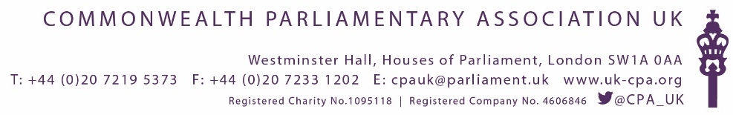
JOB SPECIFICATION
CPA UK works on behalf of both Houses of Parliament and the wider CPA to provide resources, support and peer to peer learning for parliamentarians throughout the Commonwealth. CPA UK is headed by a Chief Executive who is Secretary of the CPA UK Branch and Regional Secretary to CPA British Islands and Mediterranean Region. CPA UK is organised into three teams to plan and deliver its work. CPA UK is funded by the Houses of Parliament and leverages additional external funding for strategically aligned projects.

CPA UK is looking for an effective digital communicator to produce content in a fast-moving international environment.

We need someone who is fluent in social media, is audience focused and able to create engaging content that will capture the attention of our key stakeholders.

This role requires an individual that is confident using new formats, creating and disseminating content across all our digital channels and delivering and analysing performance on our platforms.

You will need to be confident in developing social media channel strategies, using analytics tools and content creation software.

The person in this role will also need strong writing and storytelling skills, and attention to detail as well as being able to work at pace.

Your work will directly to support the delivery of an externally-funded project: Good Governance, Parliamentary Oversight and Accountability across the Commonwealth.

Job details

• Develop and deliver social media strategy in line with CPA UK projects
• Manage deployment of content across digital channels
• Lead on content development for key programmes, events and campaigns
• Collaborate with CPA UK teams, UK Government departments and an international network of CPA branches / Commonwealth parliaments
• Use data and other insight to evaluate performance and inform strategic decisions
•Help develop new ways of storytelling in the digital environment

Who are we looking for?

Essential Criteria:
• Able to manage social media channels
• Able to conceptualise and create content
• Able to distil complex information and explain it concisely
• Able to deliver at pace against competing deadlines
• Strong writing and storytelling skills
• Excellent teamwork skills

Desirable Criteria:
• Experience with Adobe Creative suite, including Premiere Pro and After Effects
• Experience in analysing in-platform analytics to evaluate performance
• Interest in international relations

Personal Attributes & Skills:
• You will be collaborative, confident, thoughtful and authoritative
• Maintain sound judgement even under pressure
• Ability to spot trends and adapt plans quickly
• Willingness to bring ideas to the table
• Value and use insight to evaluate performance and improve output
• You’ll be curious, creative and keen to explore new tools, techniques and formats

MANAGEMENT RESPONSIBILITIY
No direct line management responsibility
ADDITIONAL INFORMATION REGARDING THE POST
LOCATION | The post is normally based in the CPA UK offices on the Parliamentary Estate. Mobile and flexible working arrangements are sometimes required.  Please note that currently due to Covid-19, all CPA UK staff are working from home. This is regularly reviewed and staff are currently being consulted on hybrid working arrangements (ie working at home some days and some day (s) on the Parliamentary Estate) to commence in September 2021.
HOURS | The standard working week is 35 hours with one hour per day unpaid for lunch.  Some evening, weekend and occasional public holiday working will be required in support of CPA UK programmes.  Annual leave – 35 days per financial year of which 5 days are to be taken over Christmas and 2 days at Easter.
FOR FURTHER INFORMATION | Visit www.uk-cpa.org

QUALIFICATIONS
Essential
A university degree / relevant educational qualification or relevant experience of working in a similar role/subject area

Desirable
An understanding of how Parliament works, including the legislative process and parliamentary oversight, including parliamentary committees.

